Lyn
Creative Directional Goals:
Engaging intentionally with women’s spiritually
I agree with other Residents that there is some dynamic "pull" as part of the Enso group dynamic. While the group was going on, I started feeling a really strong urge to go back to the idea of spiritual constructions such as spirit dolls, Encantos, and altar and studio guardians.
There have been some synchronous outside pushes in that direction, too. I got an invitation to show some of my Goddess clay constructions at the The Association for the Study of Women and Mythology Virtual conference in July. Then the owner of the main gallery where I show my work emailed and said she just sold the last of my 3-D wall pieces, a cross between spirit dolls and neo-santos, and she wants a lot more new ones.

Those pieces are the same kind I'm showing in the ASWM exhibit in July.

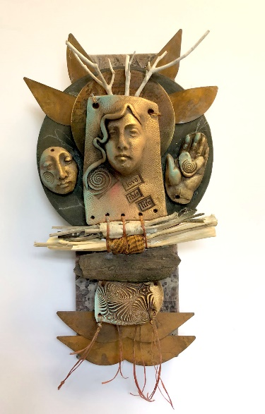

Right after that, a friend sent me an abstract of her dissertation - here's her summary opening: The proposed dissertation is a heuristic inquiry into sacred artmaking as a practice that develops and explores Goddess consciousness, allowing for personal transformation and emotional healing.

I am definitely going to keep in close touch with my friend Jessica, the dissertation writer. She also uses my faces for her spirit dolls - I met her at a retreat years ago when I was teaching with Joanna Powell Colbert, who is another great friend and mentor.

The older I get, the more I pay attention to this synchronicity. And I think being a part of The Enso Circle kind of made it happen. It's kinda woo-woo, but it's valid.

I guess I have my marching orders from the universe. I will produce a series of five spiritual constructions with wood, wax and nixed media during this twelve week term to show in an upcoming exhibit.

Studio Goals:

Spend at least twelve hours a week in the separate encaustic/mixed studio.
Promote the Spirit Doll faces as a concept on my Etsy shop.
Finish a major workshop by the end of summer as well as the Myth and Mist workshop for Painting with Fire.

Organizational Goals:

Get all of the duplicate files off my computer and clean up (discard unusable) phone images.

