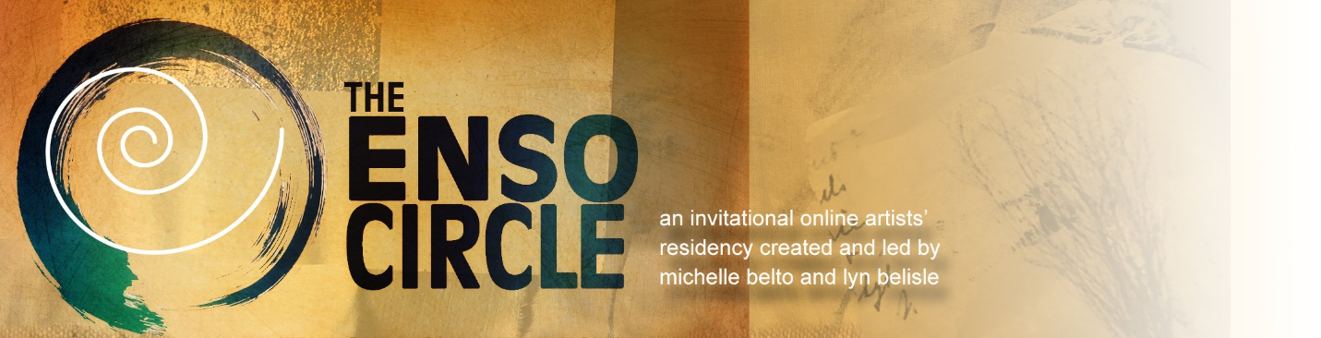
Special to the Enso Circle by Waldinei (Wally) Lafaiete
Question and Answers from Community Experts
Wally Lafaiete, a resident in the Fall Term 2021, a professional photographer and an assemblage artist, shared his technique for capturing 2-D and 3-D artwork against a black background
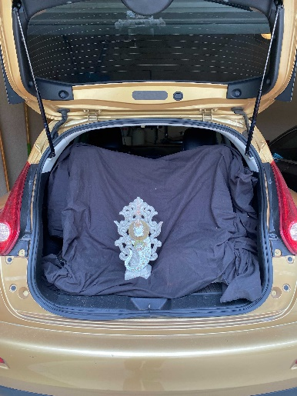
Wally, I noticed that your recent work looks stunning against the black background. Why do you like your assemblages silhouetted against black? How do you get that amazing quality?
Wally: I like black backdrops because it makes the artwork standout, and the image looks like a photo in a museum catalog. Shooting against a black backdrop is actually pretty easy. I photographed this piece in the back of my car at Crystal Bridges Museum. I wanted to give it to an artist friend, but I also wanted a good image for my records. The first image is the result of that shoot. The second image is a recreation of the setup I used.

That is amazing! You must have done a lot of work in a photo editing program like Photoshop to get that museum quality look.
Wally: The real trick is to keep the black background away from your piece, otherwise the camera will capture the creases in the fabric.

Tell us about the camera you used and how you edited the image. You must have a high-quality camera and an expensive editing program that you use.
Wally: Well, yes, I do have good cameras, studio lighting and Adobe programs but for this image, I didn’t have all of that. I used my iPhone. These newer cell phones are very sophisticated and can produce better images that you would think. If you do use editing software, increase the contrast. That will flatten the background. The artwork will seem to float in the composition.

If I prefer not to use my car trunk for photographing my artwork, (laugh) what kind of fabric would I purchase and how would I hang it if I want to shoot in my studio?
Wally: (Laughing) Good question. Most of us wouldn’t think about documenting our artwork in our car trunk, but this illustrates that you can. You can use almost any kind of fabric that doesn’t have a sheen. A black table cloth or a length of black cotton works. You can even use black paper or black cardstock or poster board. I suggest ironing the fabric or use a spray bottle of water to get rid of creases before you shoot your work. You can even put the fabric in the dryer for a few minutes. When I am doing studio photography, I often use a wet black fabric backdrop. The wet fabric also hangs better. The trick, though, is still to keep the background away from the subject matter in an area where the backdrop is getting less light than the subject matter.

Many of our residents are painters or collage artists with most of their work being two dimensional. I can see how three-dimensional art can easily sit far away from the backdrop when you use Lyn’s approach of sweeping paper into an arc from a cabinet to the countertop. But how does this work for two-dimensional pieces of art that are often shot hung on the wall?
Wally: You can shoot two-dimensional work the same way, you just have to find a different way to hang the artwork. The hanging system can be as simple as placing a broom handle on the backs of two chairs and hanging the work with nylon thread. The broom will serve as a pole to hang the art work. You can also use a small support stand system that is very affordable.

I can see how the stand would support a black cloth backdrop, but I still don't get how you would hang a canvas or panel. I don’t see how the stand would support large work.
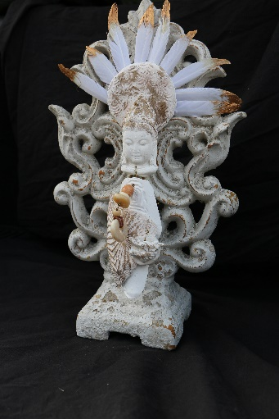
Wally: If the weight is a concern, I would just recommend covering a chair (or two) with the black cloth and standing the artwork on the seat of the chair, especially if the work is on a panel that could stand up on its own. You could also place books or something as a support in the back of your art if the painting is on canvas and can’t stand on its own. Look back at the image of my artwork in the trunk of the car. Even though the art was fairly close to the black backdrop, I was still able to make the cloth creases disappear when I cranked up the contrast during post production. Here is that image without any editing. You can see the creases.
Moving closer or away from the frame will also change the exposure and how the background will look for post-production. If you look at the photo that I took of the back of my car you will see that I was too far away from the backdrop cloth that it came out blueish, so distance from the image of you are shooting is also important.

You speak about post production. I assume you mean editing. Do you recommend Photoshop or some other program? Are there any other tricks that we might try to get good images of our work?
Wally: I like Adobe Lightroom as a more intuitive alternative to editing such things as contrast and exposure. Don’t discount the editing software in your phone. Here are a couple of YouTube videos that are helpful. Changing the Exposure on an iPhone. And Manually Adjusting your iPhone Exposure.
If you prefer to shoot your art work hanging on the wall, you can use a quick Remove the Background online app and then paste the image on a black page in Microsoft Word.

